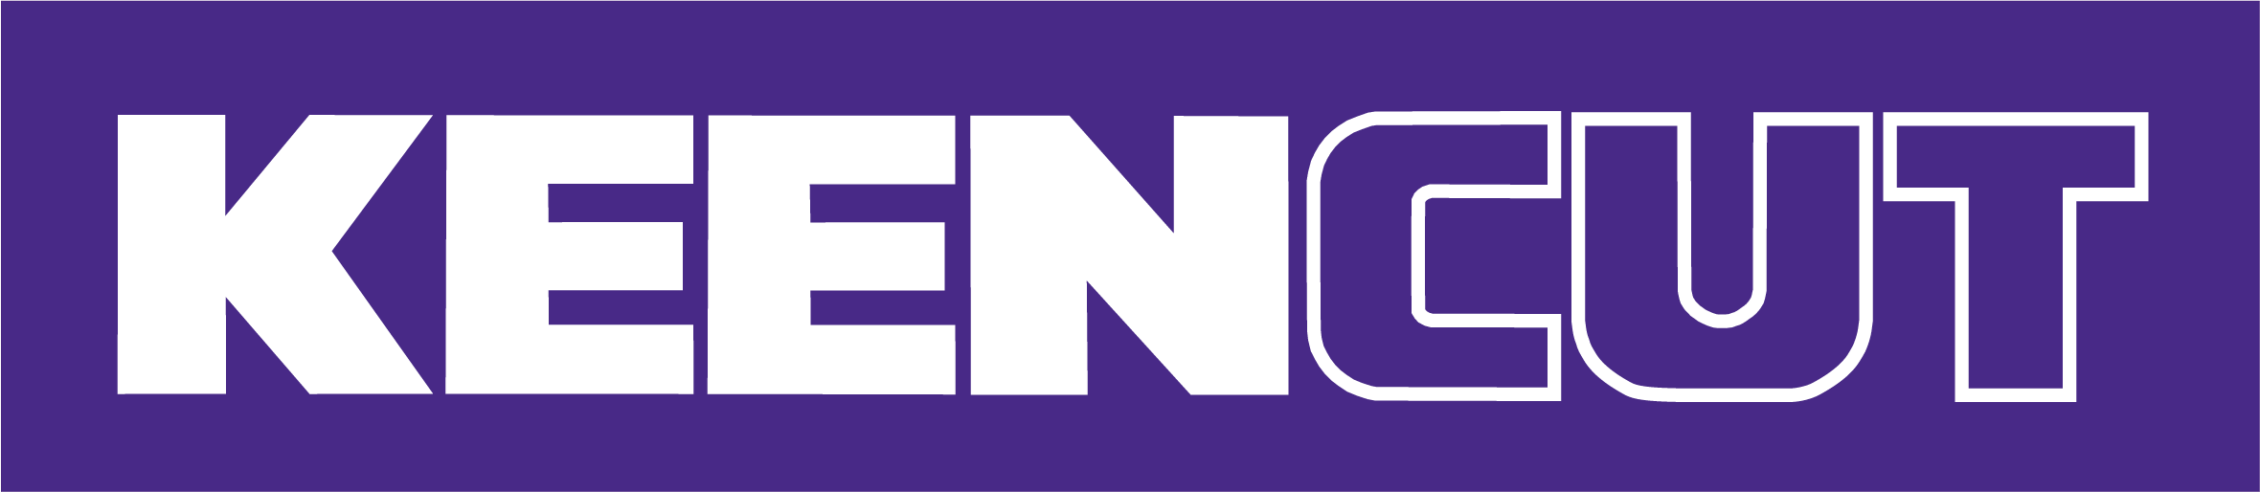
Easy to use, incredibly versatile, and exceptionally accurate.
Keencut cutting machines improve your business!

Acclaimed by signmakers, printers, and framers worldwide, Keencut is the market-leading solution for your finishing needs.

Here’s ten reasons why a Keencut cutter is the perfect choice!
1. Slash production time
Keencut cutters reduce production time and increase your workflow. It’s about speeding up productivity with the reassurance of a precise, flawless finish.
2. Guaranteed accuracy
Keencut machines are precision calibrated and made from quality components, so unlike other manufacturers, Keencut specifies an accuracy level for every cutter and a comprehensive 5-year guarantee.
3. Incredibly versatile
Keencut machines cut a wide range of rigid, semi-rigid and flexible materials. And, if there is a new material we do not list, we will test it and advise on the best cutting process.
4. Reduced waste
Wasted materials cost money! With Keencut’s cutting accuracy, you cut precisely, reducing costly mistakes and minimising waste.
5. Clean cutting
Every Keencut cutter cuts and finishes without creating debris. There’s no dust to damage printer heads or create flaws in your vinyl application. Keencut cutters are regularly fitted to Applicator Tables. Just think of all that time saved on vacuuming the workshop!
6. Cut and finish in one action
With a Keencut cutter, you cut and finish in one action. There’s no need to deburr and no sharp edges. The cutting action is smooth and requires minimal effort.
7. Perfect repeatability
Keencut technology ensures accurate, repeatable cutting to produce precise, identical pieces.
8. Reduced staffing costs
With a Keencut cutter, an inexperienced operator can create perfect results in moments. One person can align and cut materials regardless of board size or thickness.
9. No power costs or lengthy maintenance
There are no additional power costs when using Keencut machines. You do not require electricity, and the maintenance is minimal.
10. Cut your own
With a Keencut cutter, everything is under your control. You have no delays waiting for pre-cut boards to arrive, no extra costs, or quality issues. And you get to use any offcuts.
Check out our product pages to discover which Keencut cutting machine best suits your needs

