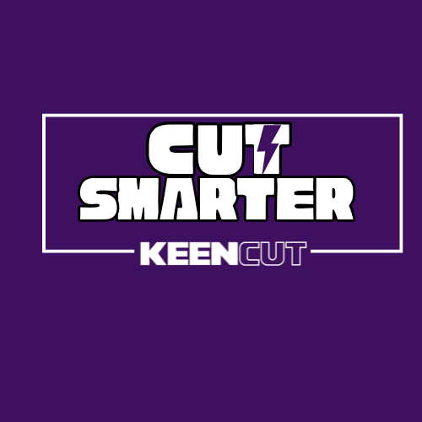

**Cut Smarter with the Keencut SteelTrak!**

The Keencut SteelTrak transforms the way you work, allowing you to **Cut Cost, Cut Time, and Cut Risk.** Here’s how the Keencut SteelTrak does it:

**Cut Cost: Maximum Efficiency, Minimal Waste**

According to customer surveys, users report **over 30% reduction in material waste** after switching to the SteelTrak.

The SteelTrak is not just a cutting tool - it’s an investment in your business. With guaranteed accuracy and precision, it delivers clean, perfect cuts every time; this means fewer mistakes and, more importantly, it **cuts material waste by over 30%.**

But the savings don’t stop there. With the SteelTrak, you consolidate multiple cutting tasks into one machine. You can cut rigid, tough Aluminium and Steel Composite Panels, foam board, fluted plastics, corrugated card, mountboard, and even expertly V-groove aluminium composite for sign trays. You are getting a versatile, all-in-one solution that cuts costs by **eliminating the need for** **multiple machines.**

And, because the SteelTrak is built with the highest quality components, you’re investing in **a tool that will last for years and years** — even under heavy-duty, every day demands. Less downtime, fewer repairs, and longer-lasting performance mean long-term savings.

**Cut Time: Speed Meets Precision**

In a recent customer survey, users reported **production speed increases of up to 50%** with the SteelTrak — simply by upgrading their workflow.

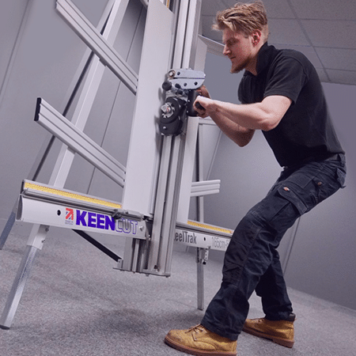

Time is money, and the SteelTrak is designed to save you both. Thanks to its **fast alignment, fast setup, and fast cutting**, the SteelTrak ensures you get the job done quickly without sacrificing quality. Whether cutting ACP with one pass to create a perfect, safe edge or setting up identical panels for rapid, high-quality finishes, the SteelTrak makes it easy.

You’re boosting productivity while maintaining a perfect result every time; this means faster project completion, more work in less time, and a more efficient workflow.

**Cut Risk: Safe, Clean, and Precise**

Safety is a top priority when it comes to cutting materials. By eliminating the need for hand knives, the **SteelTrak offers a safer solution to protect your team and your business.**

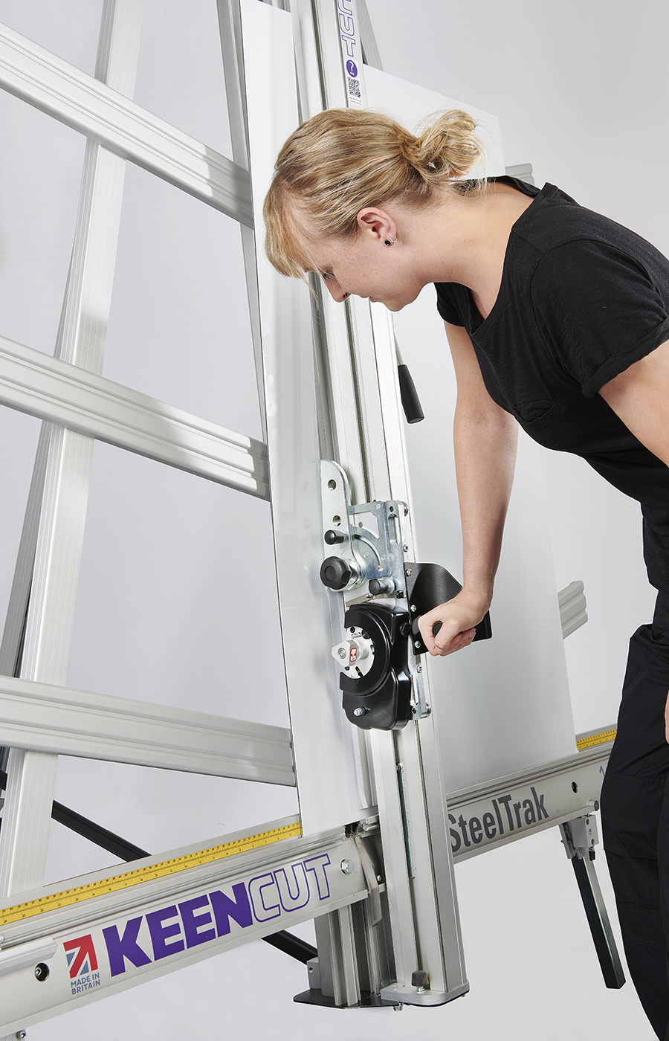

Hand knives, though commonly used to cut materials, are a source of constant risk in production environments. In fact, industry reports show that **up to 50% of hand-knife cutting leads to injury** — a risk you can’t afford.

The Keencut SteelTrak is the safest choice. The safety benefits don’t stop at just replacing the need for hand-knife cutting. Unlike traditional cutting methods that produce dangerous dust and debris, the **SteelTrak cuts cleanly**. Dust can be hazardous to your health and your expensive printers’ health. Dust particles on your applicator table also damage the quality of your finish. With the SteelTrak, you’re keeping your workspace cleaner and safer.

**Smarter Cutting = Smarter Business**

With 50% faster production, 30% less waste, and a design that prioritises your safety, a **Keencut SteelTrak is the 100% Smarter Choice.**

Why risk mistakes, injuries, and wasted materials when you can

Cut Smarter with Keencut?