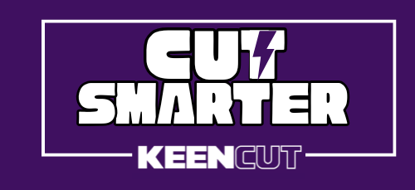

Smarter Print Finishing Starts Here! Why a Keencut Cutter Is the Ultimate Upgrade for Your Workshop
In the competitive world of signage and display graphics, print finishing is where precision, efficiency, and professionalism come together. Yet, many workshops still rely on outdated or manual cutting tools that slow down production, generate waste, create a poor finish, and increase the risk of costly errors — or worse, injury.
If you’re ready to elevate your workshop’s capabilities, the Keencut SteelTrak might just be the smartest upgrade you can make.
We asked our expert (NAME) to talk us through the benefits.

A Smarter Way to Cut Costs
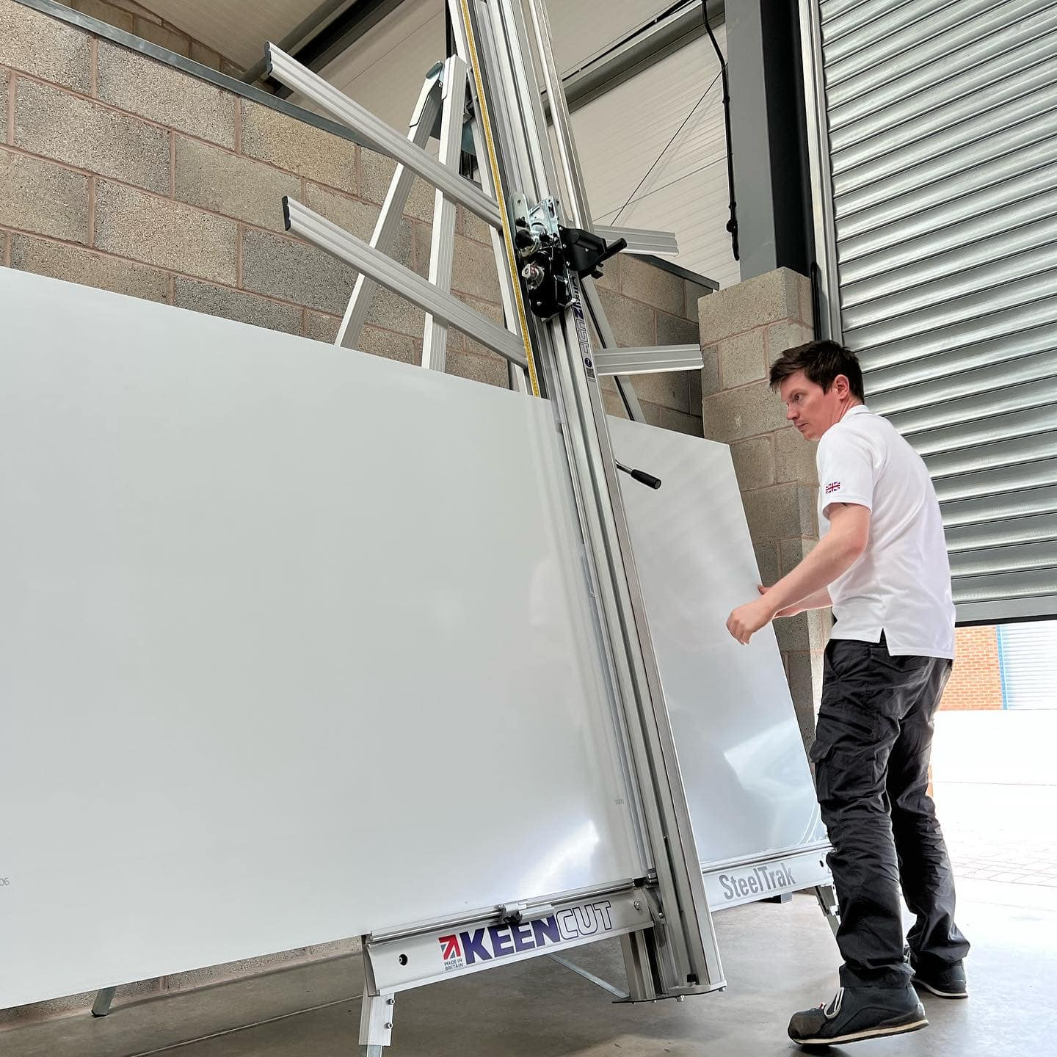
For many print professionals, material waste can quietly eat into profit margins. However, users of the Keencut SteelTrak report a remarkable 30% reduction in waste, according to recent customer surveys.
How? You just need to do one cut with a SteelTrak to see how easy it is to replicate fast, precise, consistent cuts — which means fewer errors, less discarded material, and a more streamlined operation.
Whether you're working with Aluminium Composite Panels (ACP), foam boards, corrugated plastics, mountboard, or even performing V-grooves for sign trays, the SteelTrak handles it all. That versatility replaces the need for multiple machines, saving you valuable floor space and investment costs. Adding the ability to quickly V-groove sign trays is a fantastic way to bring new products to your offering.
I am always impressed by the Keencut build quality. With such high-grade components, the SteelTrak, like all Keencut products, is designed for longevity. For busy production environments, that means fewer breakdowns, less downtime, and long-term savings that continue well after the initial investment.

Faster Production Without Compromising Quality
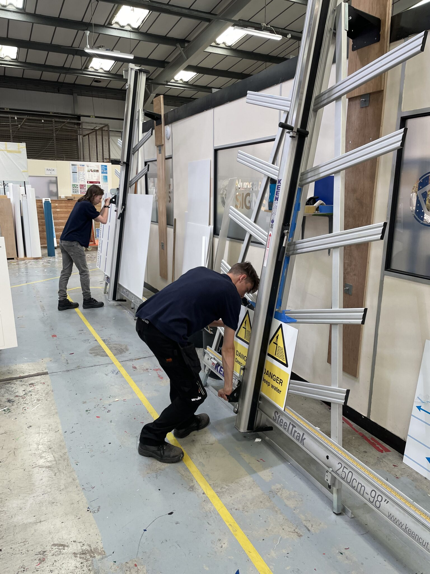
Ask any production manager what they need more of, and you’ll probably hear the same answer: time. Here too the SteelTrak delivers.
In a recent survey, Keencut customers reported up to 50% faster cutting speed —just imagine that impact on your workflow! It’s fast but it’s accurate – so speed and quality.
Thanks to fast setup, accurate alignment, and seamless cutting performance, operators can complete jobs quicker while still achieving a high-quality finish. Whether you're cutting through tough composite materials or replicating multiple identical panels, the SteelTrak makes the process smooth and efficient. That means more output, quicker turnaround times, and a clear path to greater profitability.

Reducing Risk — and Protecting Your Team
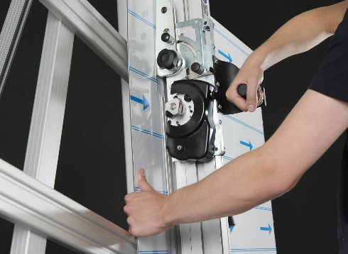
Safety in the workshop is non-negotiable. Many workshops still opt for cutting with a knife by hand. Unfortunately, traditional hand-cutting tools remain a leading source of injuries. Industry reports indicate that up to 50% of hand-knife cutting results in injury — a sobering statistic for any business owner.
The SteelTrak removes that hazard. With its guided cutting system, you eliminate the need for hand knives and introduce a safer, more controlled process for your team.
The safety benefits go even further. Unlike some cutting methods that create harmful dust or debris, the SteelTrak’s design keeps your workspace clean and safe — protecting both your people and your equipment, especially delicate printers that can be damaged by airborne particles. There’s also no dust particles on your applicator table when you apply a vinyl.

Smarter Cutting Leads to Smarter Business
When a single piece of equipment can improve quality, speed, safety, and ultimately, profit, it’s more than a tool — it’s a competitive advantage.
With customer-reported results of 50% faster output, 30% less waste, and significantly safer operation, the Keencut SteelTrak isn’t just a smarter way to cut. It’s a smarter way to do business.

To Cut Keencut Smarter contact us today on (CONTACT DETAILS)

